Stock Manager Application.

In this application we are having two spring-boot application

1. User-Stock-Service

2. Stock-Price-Service

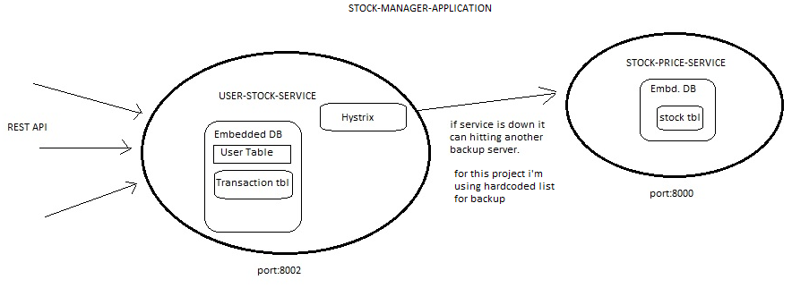

1. Stock-Price-Service provides list of stocks and their price. It is using embedded H2 Database and running on embedded tomcat server on port 8000

Various Rest point are:

1. <http://localhost:8000/stock/> (GET) for list of stocks and their details.

2. [http://localhost:8000/stock/{stockname}](http://localhost:8000/stock/%7bstockname%7d) (GET) details of given stock.

2. User-Stock-Service handles new user registration and stock transaction.

This service calls Stock-Price-Service for fetching details of stocks. It is using Hystrix Circuit breaker,

If Stock-Price-Service is down it will fetch data from hard-coded list. We can have another backup server

for Stock-Price-Service.

It is using embedded H2 Database and running on embedded tomcat server on port 8002

Various Rest point are:

1. <http://localhost:8002/user/> (GET) for list of users and their details.

2. [http://localhost:8002/user/{username}](http://localhost:8002/user/%7busername%7d) (GET) details of given user.

3. <http://localhost:8002/user/> (POST - sample: {id:-1,name:USER1}) adding new user.

4. [http://localhost:8002/user/{username}](http://localhost:8002/user/%7busername%7d) (DELETE) delete the given user.

5. [http://localhost:8002/user/stockservice/stockprice/{stockname}](http://localhost:8002/user/stockservice/stockprice/%7bstockname%7d) (GET) details of given stock from Stock-Price-Service.

6. [http://localhost:8002/user/stockservice/buystock/{user}/{stock}/{quantity}](http://localhost:8002/user/stockservice/buystock/%7buser%7d/%7bstock%7d/%7bquantity%7d) (GET) buying stock.

7. [http://localhost:8002/user/stockservice/viewStock/{user}](http://localhost:8002/user/stockservice/viewStock/%7buser%7d) (GET) get details of user stock.